Digital Storytelling in English Language Arts

Storyboard

By

Nancy Blair
ETEC 644

Project: DIGITAL STORYTELLING | Screen: | 1 | of | 16
Date:

Multimedia Storyboard

Screen Description: Opening Title Page

Screen Layout:
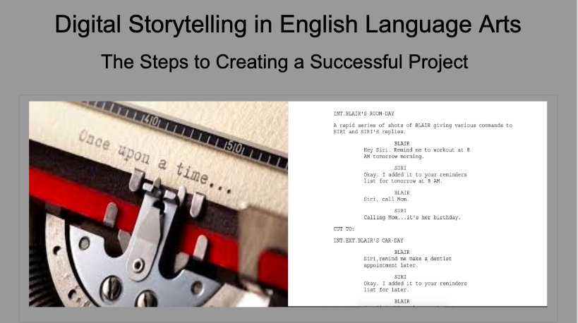

Text Attributes: | Title in Times New Roman
Still Images: | 1. Image of typewriter and 2. Image of screenplay format
Moving Images | none
Animation: | none
Video: | none
Audio
Speech:
Music:
Sound Effects:
Interactivity: | Facilitator verbally presents concept to class
Navigation
From Screens: | Facilitator controls the progress of one screen to the next, and from one module to the next.
To Screens:

Project: DIGITAL STORYTELLING | Screen: | 2 | of | 16
Date:

Multimedia Storyboard

Screen Description: Image and graphics of a typical bored English student complaining about having to write a essay. This is first half of the opening Attention Grabber.

Screen Layout:
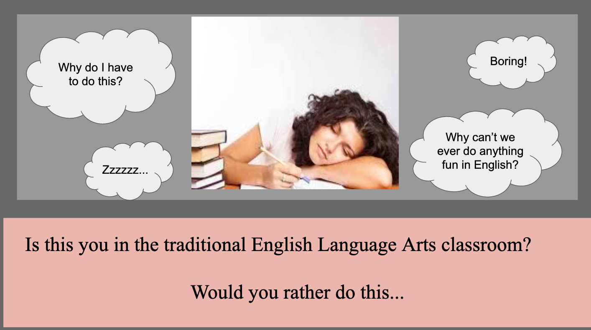

Text Attributes: | Text in Times New Roman and Arial
Still Images: | 1. Image of bored student struggling to write a traditional essay 2. Bubble shapes indicating the negative thoughts of the student
Moving Images
Animation: | none
Video: | none
Audio
Speech: | Add dialogue for each of the bubbles
Music: | Maybe.
Sound Effects: | Time allowing
Interactivity: | Instructor to learner…”How many of you feel this way about writing essays?” followed by show of hands or discussion
Navigation
From Screens: | Facilitator controls the progress of one screen to the next, and from one module to the next.
To Screens:

Project: DIGITAL STORYTELLING | Screen: | 3 | of | 16
Date:

Multimedia Storyboard

Screen Description: 2nd Attention Grabber :45 high video montage of example student work

Screen Layout:

Text Attributes: | None
Still Images: | no
Moving Images
Animation: no
Video: | :45 original video montage
Audio: | Sound is the original audio from each clip
Speech:
Music:
Sound Effects:
Interactivity: | Audience viewing and reacting to montage (hopefully with enthusiasm)  Facilitator-learner presentation/questions/discussion
Navigation
From Screens: | Facilitator controls the progress of one screen to the next, and from one module to the next.
To Screens:

Project: DIGITAL STORYTELLING | Screen: | 4 | of | 16
Date:

Multimedia Storyboard

Screen Description: Facilitator will present the Performance Objective and Subordinate to the learners

Screen Layout:
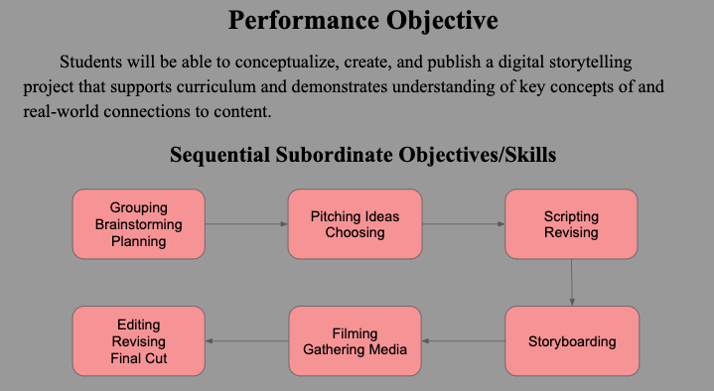

Text Attributes: | Headers are Times New Roman, Text in Flow chart is Arial
Still Images: | Graphic Organizer/Flow Chart
Moving Images
Animation:
Video:
Audio
Speech:
Music:
Sound Effects:
Interactivity: | Instructor-learner
Navigation
From Screens: | Facilitator controls the progress of one screen to the next, and from one module to the next.
To Screens:

Project: DIGITAL STORYTELLING | Screen: | 5 | of | 16
Date:

Multimedia Storyboard

Screen Description: Explanation of connection to curriculum, objectives and standards addressed, project prompt and requirements, timeline of project, Unit Plan Scope and Sequence is link a to the complete document.

Screen Layout:
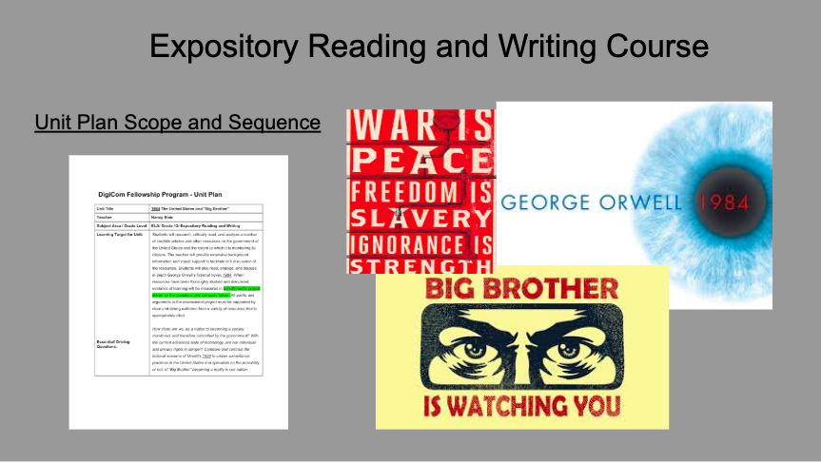

Text Attributes: | Times New Roman headings
Still Images: | 4 images. 1, 2, 3, are images from 1984, 4. Image of Unit Plan document linked to the page
Moving Images
Animation:
Video:
Audio
Speech:
Music:
Sound Effects:
Interactivity: | Instructor presents Unit Plan and answer student questions about the process
Navigation | Facilitator controls the progress of one screen to the next, and from one module to the next.
From Screens:

Project: DIGITAL STORYTELLING | Screen: | 6 | of | 16
Date:

Multimedia Storyboard

Screen Description: Explanation and link to online brainstorming map. Instructions for assignment and sharing of document are included

Screen Layout:
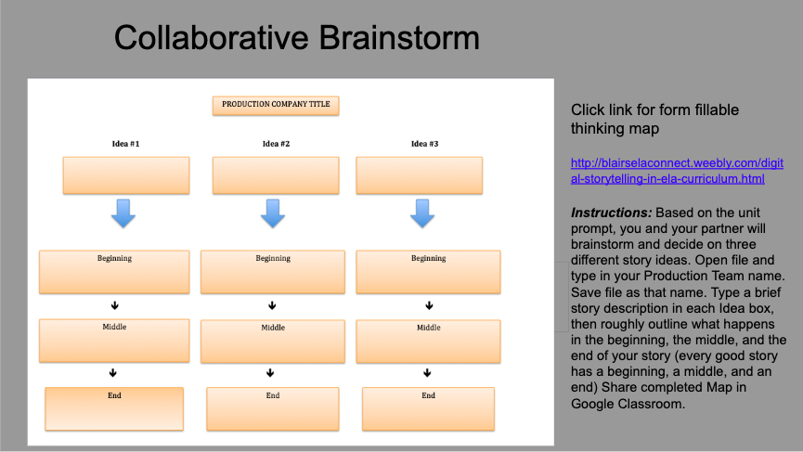

Text Attributes: | Titles and instructions in Times New Roman, Text instructions
Still Images: | 1. Interactive thinking map
Moving Images
Animation:
Video:
Audio
Speech: | QuickTime Screencast explanation of map and requirements for completing
Music:
Sound Effects:
Interactivity: | Link to interactive map/ Facilitator-learner presentation/questions/discussion
Navigation
From Screens: | Facilitator controls the progress of one screen to the next, and from one module to the next.
To Screens:

Project: DIGITAL STORYTELLING | Screen: | 7 | of | 16
Date:

Multimedia Storyboard

Screen Description: Images of the brainstorm/ collaboration procees

Screen Layout:
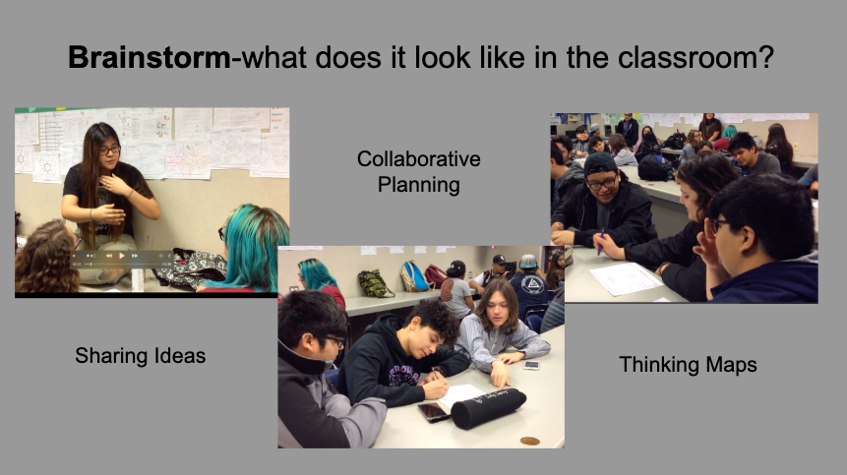

Text Attributes: | Times New Roman/Caption over Video “What It Looks Like in Practice”
Still Images:
Moving Images
Animation:
Video: | Original video documentation of lesson in action (Screen layout is screenshots of videos
Audio | Audio is included in original videos
Speech:
Music:
Sound Effects:
Interactivity: | Learner-learner brainstorm/questions/discussion. Instructor monitor progress
Navigation
From Screens: | Facilitator controls the progress of one screen to the next, and from one module to the next.
To Screens:

Project: DIGITAL STORYTELLING | Screen: | 8 | of | 16
Date:

Multimedia Storyboard

Screen Description: Video demonstration of what the Pitch looks like in the classroom

Screen Layout:
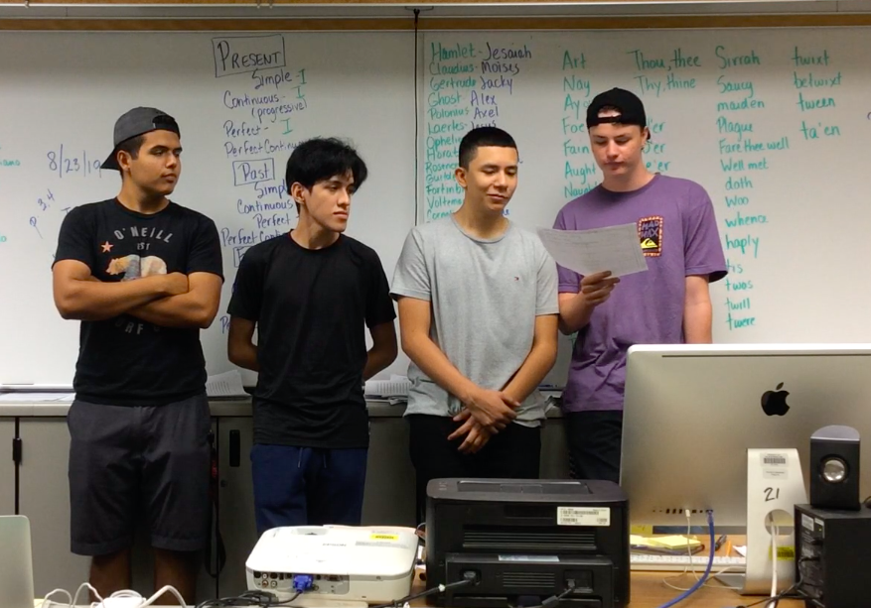

Text Attributes: | Times New Roman /Caption over Video “What It Looks Like in Practice”
Still Images:
Moving Images
Animation:
Video: | Original video documentation of lesson in action (Screen layout is screenshots of videos
Audio
Speech: | Audio is included in original videos
Music:
Sound Effects:
Interactivity: | Learner-learner, learner-instructor presentation/questions/discussion
Navigation
From Screens: | Facilitator controls the progress of one screen to the next, and from one module to the next.
To Screens:

Project: DIGITAL STORYTELLING | Screen: | 9 | of | 16
Date:

Multimedia Storyboard

Screen Description: Story elements and the Story Arc

Screen Layout:
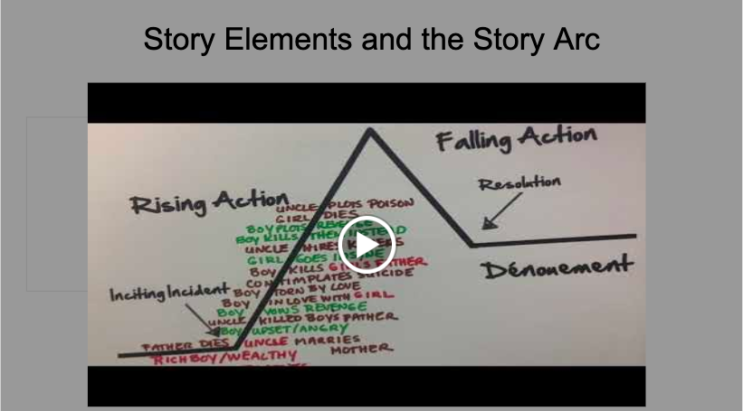

Text Attributes: | Times New Roman “Story Element and the Story Arc”
Still Images:
Moving Images
Animation:
Video: | Original video modeling concepts
Audio
Speech: | Audio is included in original videos
Music:
Sound Effects:
Interactivity: | Facilitator-learner presentation/questions/discussion
Navigation
From Screens: | Facilitator controls the progress of one screen to the next, and from one module to the next.
To Screens:

Project: DIGITAL STORYTELLING | Screen: | 10 | of | 16
Date:

Multimedia Storyboard

Screen Description: Scripting with Google Add on Screenplay formatter
Scripting with Google Add on Screenplay formatter

Screen Layout:
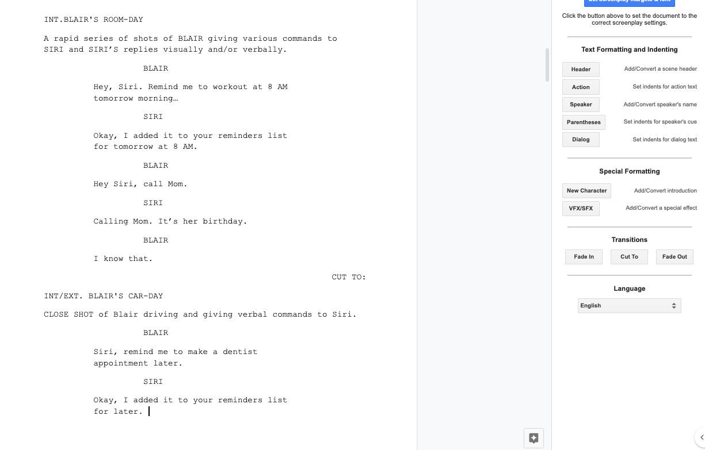

Text Attributes: | Titles in Times New Roman  Text in Screenplay Formatter in Times New Roman
Still Images:
Moving Images
Animation:
Video: | Screencast demonstration
Audio
Speech: | QuickTime audio screencast over visual demonstration
Music:
Sound Effects:
Interactivity: | Learner-content, learner-learner, Scripts shared with instructor in Docs/Classroom
Navigation
From Screens: | Facilitator controls the progress of one screen to the next, and from one module to the next.
To Screens:

Project: DIGITAL STORYTELLING | Screen: | 11 | of | 16
Date:

Multimedia Storyboard

Screen Description: What it looks like in the classroom. Video montage of students scripting individually on Chrome Books with Google Add on Screenplay Formatter.

Screen Layout:
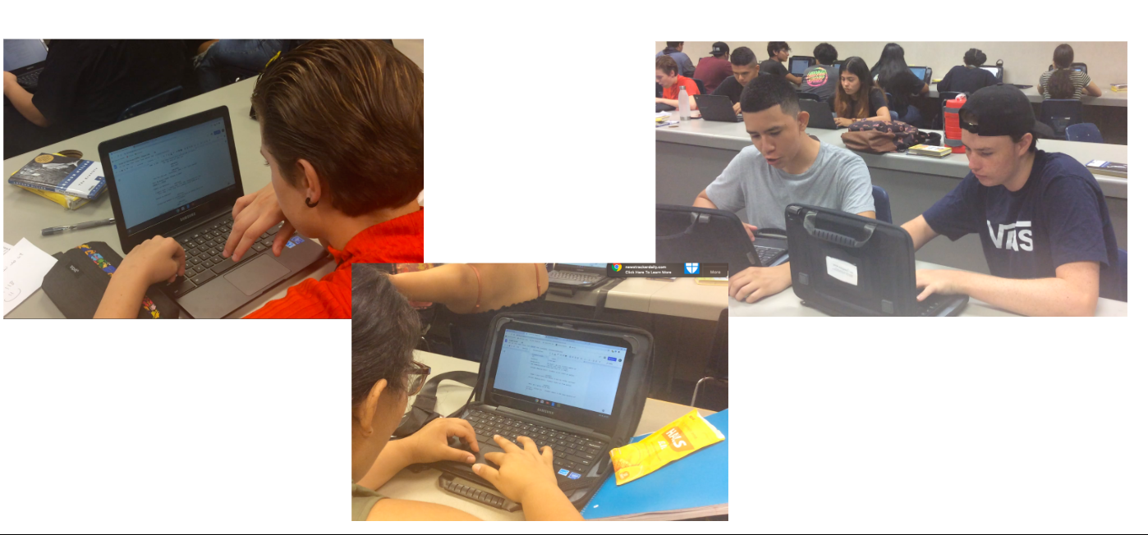

Text Attributes: | Times New Roman caption over Video “What It Looks Like in Practice”
Still Images: | Original video documentation of lesson in action (Screen layout is screenshots of videos
Moving Images | Audio is included in original videos
Animation:
Video: | Original video documentation
Audio | Audio is included in original videos
Speech:
Music:
Sound Effects:
Interactivity: | Learner-content/ learner-learner, instructor-learner
Navigation | Facilitator controls the progress of one screen to the next, and from one module to the next.
From Screens:
To Screens:

Project: | Screen: | 12 | of | 16
Date:

Multimedia Storyboard

Screen Description: 1st, 2nd 3rd Draft Revision Process

Screen Layout:
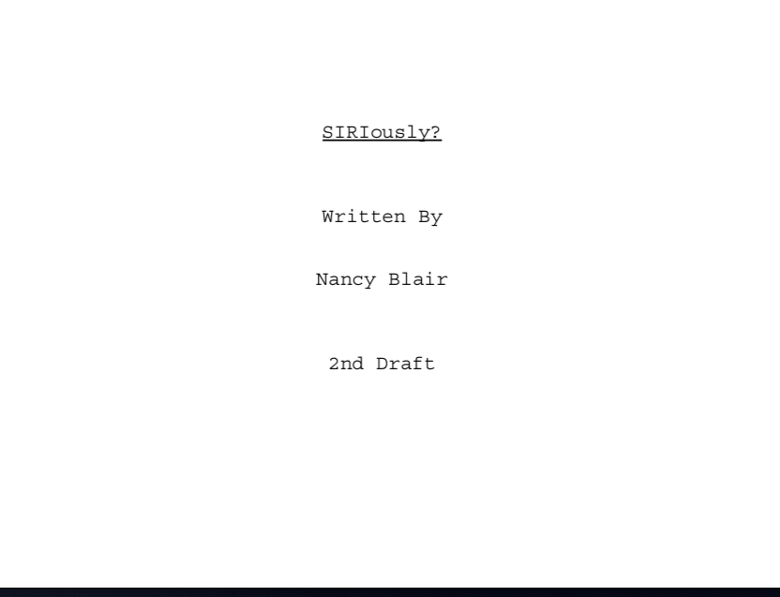

Text Attributes: | Times New Roman Caption over The Revision Process “
Still Images:
Moving Images
Animation:
Video: | Video montage of layers and layers of script pages, corrections, and revisions
Audio | Undecided
Speech:
Music:
Sound Effects:
Interactivity: | Instructor-learner
Navigation | Facilitator controls the progress of one screen to the next, and from one module to the next.
From Screens:
To Screens:

Project: DIGITAL STORYTELLING | Screen: | 13 | of | 16
Date:

Multimedia Storyboard

Screen Description: Still and video examples of a proper Storyboard, and its content

Screen Layout:
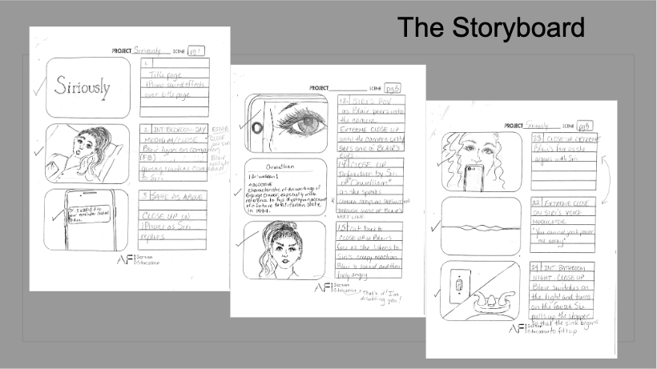

Text Attributes: | Times New Roman Caption/ The Storyboard
Still Images: | Combination of still and scrolling images of visual and textual requirements of the storyboard
Moving Images
Animation:
Video: | See above
Audio
Speech:
Music:
Sound Effects:
Interactivity: | Instructor-learner
Navigation | Facilitator controls the progress of one screen to the next, and from one module to the next.
From Screens:
To Screens:

Project: DIGITAL STORYTELLING | Screen: | 14 | of | 16
Date:

Multimedia Storyboard

Screen Description: Video Montage of students filming scenes

Screen Layout:
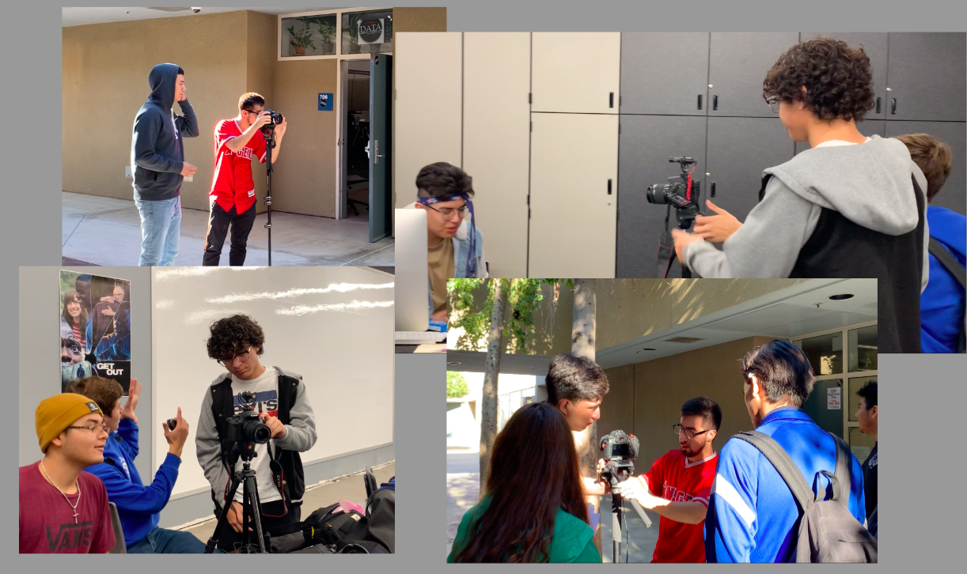

Text Attributes: | Times New Roman Caption/ Filming-Gathering Media “What It Looks Like”
Still Images:
Moving Images
Animation:
Video: | Original Video documentations of students filming
Audio | Audio is original audio captured during the filming process
Speech:
Music:
Sound Effects:
Interactivity: | Learner-learner
Navigation | Facilitator controls the progress of one screen to the next, and from one module to the next.
From Screens:
To Screens:

Project: DIGITAL STORYTELLING | Screen: | 15 | of | 16
Date:

Multimedia Storyboard

Screen Description: Video clip of student editing in Final Cut Pro
Editing in Final Cut Pro

Screen Layout:
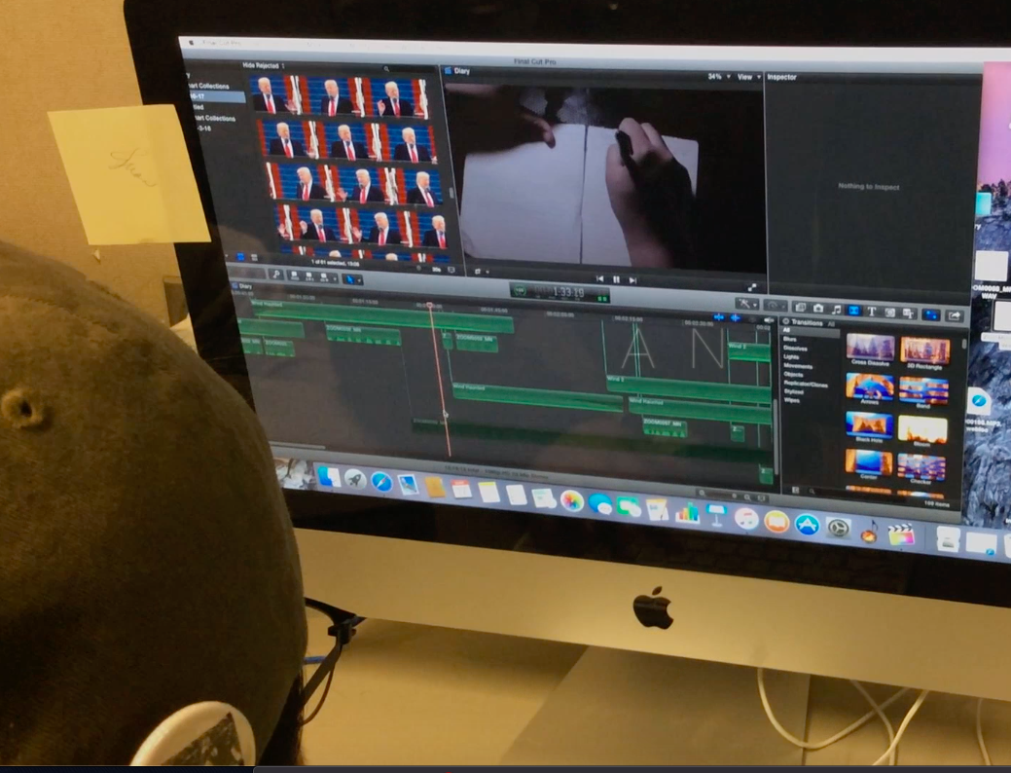

Text Attributes: | Times New Roman Caption/ The Editing and Revision Process “What it Like in Practice:
Still Images:
Moving Images
Animation:
Video: | Original Video documentations of student editing
Audio
Speech:
Music: | Music over moving image
Sound Effects:
Interactivity: | Learner-learner, instructor-learner
Navigation | Facilitator controls the progress of one screen to the next, and from one module to the next.
From Screens:
To Screens:

Project: DIGITAL STORYTELLING | Screen: | 16 | of | 16
Date:

Multimedia Storyboard

Screen Description:
Culminating Digital Storytelling Project published, shared and projected on the screen for viewing

Screen Layout:
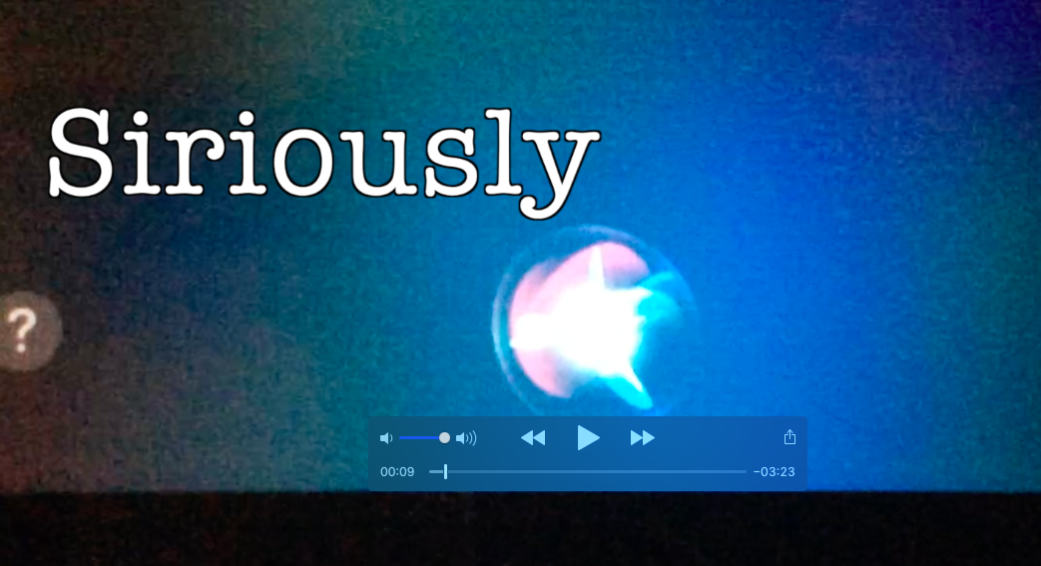

Text Attributes: | Times New Roman Caption/ The Premier “What it Looks Like”
Still Images:
Moving Images
Animation:
Video: | Original Digital Storytelling complete
Audio
Speech:
Music:
Sound Effects:
Interactivity: | Learner-Learner, media loaded to the Drive, YouTube, for shared viewing
Navigation | Facilitator controls the progress of one screen to the next, and from one module to the next.
From Screens:
To Screens:

Nancy Blair

ETEC 644 Design and Development of Instructional Materials

California State University, San Bernardino

INTRODUCTION
My design project, Digital Storytelling in English Language Arts, is based almost entirely on the learning theory of Constructivism, that is making meaning from our own individual experiences and creating “something from nothing”, if you will. Every completed task in the design of the program is original, meaning it didn’t exist before students began-hence the creation of something new. Tasks are organized in such a way that each depends the one before it in order to be completed. A successful culminating/final project cannot have been produced without the completion of the sequence of steps that precede it. Therefore the design process, outline and ordered in the way it is presented, must be strictly adhered in order to meet the
final performance objective.

COGNITIVE LOAD THEORY and MY PROJECT

There is only so much information that the human mind can handle at any one time when we are looking at short-term memory, or now as it’s referred to, working memory. This is especially true when it comes to extremely complex tasks, such as the culminating task in my instructional design. John Sweller, a major Cognitive Load Theorist tells us that when tasks are too complex “other structures and other mechanisms must be used” (2002). My project is structured in such a way that the culminating task cannot be accomplished with out following the sequence of structured activities that enable the learners to create the final project. The complexity of the task is diminished if learners conquer each step of the process that builds on the one before it. An example of an “other mechanism” to help ease the cognitive load is the group support. A team of students would contribute individual strengths and with each task completed, the skills learned will translate into long-term memory concepts, in other words, retention of knowledge.

STUDENT GROUPING

Students are grouped according to individual strengths and skills. For instance, the instructor may ask everyone in the class to raise their hand if they have camera and editing skills.
All students who raised their hand are asked to come to the front of the room. Next the instructor asks which students feel that they are strong writers and when students respond with a show of hands, the grouping process begins, facilitated by the instructor. The instructor continues to the next role and asks which students are good artists, as they will have the responsibility of creating a strong storyboard. The process continues until there are 5-8 groups with 3-5 students with varying degrees of skills until everyone in the group plays 1 or 2 vital roles on the team. The roles are: Writer, Producer/Director, Cinematographer, Audio Specialist, Storyboard Artist, Actor/Actress, and Editor. Ideally each team member should be responsible for 2 roles. The teams are formed and members decide on a formal title for their production companies.

PERFORMANCE OBJECTIVE, SUBORDINATE OBJECTIVES and TIME ALLOTMENTS

PERFORMANCE OBJECTIVE: Students will conceptualize, create, and publish a digital storytelling project that supports curriculum and demonstrates understanding of and real world connections to content.

Module | Subordinate Objectives | TIME
1 | Students will be able to brainstorm and document three story ideas that address the prompt and support content | 1 hour
2 | Students will be able to deliver a successful story pitch to an audience | 1 hour
3 | Students will be able to draft and revise a properly formatted screenplay that addresses the prompt and supports content. | 5 hours
4 | Students will be able to construct a storyboard that supports a screenplay. | 5 hours
5 | Students will be able to film and gather media for a digital storytelling project that addresses the prompt and supports content. | 5 hours
6 | Students will be able to edit media that into a project that addresses the prompt and supports content. | 5-10 hours
7 | Students will be able to revise and publish a digital storytelling project that addresses the prompt and supports content. | 5 hours
8 | Publish Final Project  (See Performance Objective Above) | 27-32 hours

Time allotted for tasks in order to achieve the subordinate objects may vary slightly, but the instructor should make every attempt to not exceed the time allowed. Otherwise, students may procrastinate, make excuses, etc. and the project may never see completion. In each module and for each subordinate objective, a series of tasks need to be completed in order for the objective to be met. These are also referred to as learning activities. Below is a flow chart that sequences the objectives and provides the action verb, in other words, the things that need to be
done in each module. Action verbs are bolded for clarity.

FLOW CHART and LEARING ACTIVITIES

Subordinate Objectives/Skills Necessary to Accomplish Performance Objectives

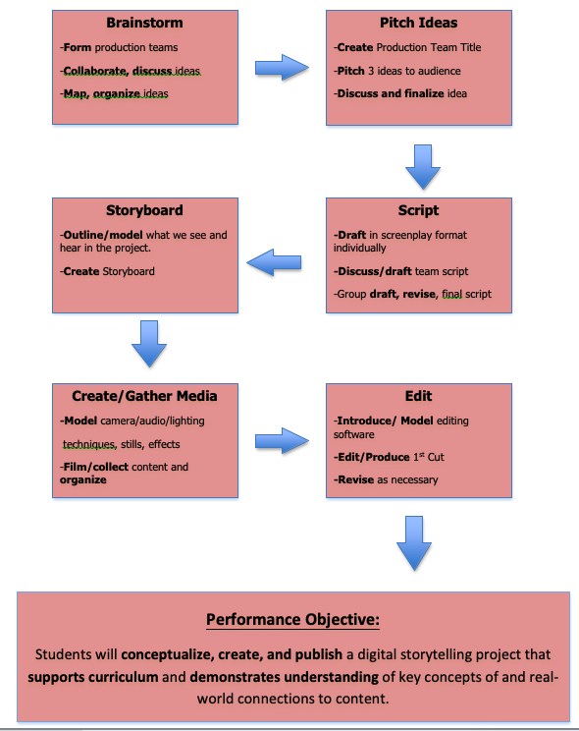

ARCS and GAGNE’S 9 EVENTS OF INSTRUCTION

John Keller’s ARCS and Robert Gagne’s 9 Events of Instruction, two prominent instructional design approaches, both contend that the first step to effective instruction is getting the interest of the learner. This is also referred to as the attention grabber, the hook, or arousing interest, to name a few. This attention-grabbing tactic may be something as simple as a brief anecdote or a short video, but scholars agree that it’s a vital early component of instruction. In my design, I begin with a by asking the learner if he or she would rather write an essay, or... here I show a :45 video montage of student projects that will hopefully arouse excitement for the project. The montage has visuals, sound, text, movement, and tension. It is intended to motivate the learner to want to make videos as opposed to writing that traditional, boring English Essay.
There is not enough time here to address my intentions for every element of ARCS, and/or every step of Gagne’s events, but these two models, along with the ADDIE are the basis for my content and sequence of presentation of content.

ASSESSMENTS and FINAL PROJECT RUBRICS

Assessment throughout modules 1-7 comes in the form of guided practice, feedback, and progress. Basically, if all tasks are completed and revised if necessary, the students may move on to the next module with its subsequent subordinate objective and set of tasks. Except for the individual 1st draft of the screenplay, all other completed tasks receive a group grade. The individual grade on the first draft of the script is to ensure that every single student is producing original writing a some point in the project path and that they may contribute some of the individual ideas to the group draft of the script. No groups move on to the next step in the process until the conditions of the previous step are met. For instance, no filming will happen until the Storyboard is complete and approved by the instructor.
The Final Project is assessed through a rubric known as S.C.A.L.E, which takes into account several areas of the entire production-story, camera, audio, look/lighting, and editing-hence the acronym. The Story aspect of the rubric carries the most weight, because the story is what drives the project. That is why so much time is spent brainstorming, planning, pitching, looking at story structure and elements, writing, revising as necessary, etc. Without a good story, you won’t have a successful project. Camera assessment includes types of shots, variety of shots, purpose for the shot, and quality of shots. For instance, if a group has only one or two shots throughout their entire projects, their point for that section of the rubric would suffer. Audio is expected to be clear and free of background noise, appropriate, and support the video.
Look includes lighting, color schemes, settings and any other visuals that contribute to the look of the video. Editing can make or break the project and is assessed by looking at everything from interesting and purposeful transitions, cuts, fades, filters, etc…to continuity. Comments are provided to explain why points may have been awarded or not. Below is an example of a S.C.A.L.E. rubric provided to a group project. The rubric is courtesy of Digicomlearning.com.

S.C.A.L.E. RUBRIC / Digital Project

Production Company:

Project Title: The Soloist

Student Names:
- Jebari Wooten
- Jaime Villa

Element | Points Possible | Points  Earned | Comments
Story | 40 | 35 | Your story is strong and I could see integration of pathos, ethos, and logos. I love your voiceover and the words you choose to persuade. The third segment works (the black and white part), however, the dialogue goes a little too far (I will be more specific when we chat). I want to re-voiceover a few things and complete this project. Also, I know that you have an explanation for not revealing whether or not you were accepted to the college at the end, but I really think it would make a huge impact if we get the feeling that you were. It gives credibility to the attempts at persuasion. Think about and we will talk further during our project conference.
Camera | 15 | 12.5 | We need opening credits or something before the scenes starts. Of course, you have a way with the camera and I loved your dialogue as you type your personal statements on the computer.
Audio | 15 | 12.5 | Sound is right on except for Alex’s dialogue when she first appears in the scene. That glitch may be able to be out altogether. We’ll look at it again. Music is appropriate and levels are acceptable.
Look-  Includes  lighting | 15 | 15 | I’m impressed with your choices and the way you can adapt according to your needs in the moment. That’s a talent that you have definitely grasped.
Editing | 15 | 15 | Great work, as I expected from you. FYI, you need to add opening and closing credits, including citing the music at the end of the film, even if it is royalty free.
Overall |  |  | I would like for you to complete this film, as I would like to enter it into Digicom. But you have to clean it up and turn in a complete Final Cut.
 | 100 | 90 | Percentage and Project Grade | 90%  A-

DESIGN DECISIONS/CONNECTIONS to LITERATURE

A number of my design decisions are guided by the studies of others in the field of digital storytelling and the world of education. Two interesting studies have affected my design, one out of UC Riverside and the other in a rural Mid-Western setting. In the latter, researchers Staley and Freeman found that applied digital storytelling in education empowers student lives and allows them to make real world connections and goals (2017). This was a factor in my adding the phrase “make real world connections to content” in my performance objective. Once a student can do that, learning becomes less of a chore and more of an “ah-ha moment”. The second research article is of particular interest to me because my students participated in the study.

Authors Vu, Warschauer, & Yim found that use of digital storytelling in a particular 12th English class versus the traditional classroom practices, for example essay writing, produced more meaningful collaboration, higher engagement, and higher rates of retention of major concepts (2019). My course is designed with repeated and sustained collaboration exercises, high engagement activities and assignments, and organized so that retention is likely. I learned that a rule of thumb for really learning a concept is that you need to be exposed to it at least seven times. There are seven modules that lead to my culminating project, so by deciding on that initial concept and returning to it over and over in every module, but the end of the course, the concept should be retainable.

References

Gagne’s 9 Events of Instruction. (2018, March 13). Retrieved December 7, 2019, from
http://citt.ufloedu/tools/gagnes-9-events-of-instructiion/.
Reiser, R.A., & Demsey, J.V. (2012). Trends and Issues in Instructional Design and Technology (3rd ed.).
Boston, MA: Pearson
Staley, B., & Freeman, L. A. (2017). Digital storytelling as student-centered pedagogy: Empowering high school students to frame their futures. Research and Practice in Technology Enhanced Learnin12 . (1), 1-17. doi. https://dx.doi.org.libproxy.lib.csusb.edu/10.1186/s41039-017-0061
Sweller, J. (2002). Visualization and Instructional Design.

Vu.V., Warschauer, M., & Yim, S. (2019). Digital storytelling: A district initiative for academic literacy improvement. Journal of Adolescent & Adult Literacy, 257. doi:https://doi.org/10.1002/jaal.962

